Pic7777777

|  |  |
| --- | --- |
| **Component of Fitness (F)** | |
| 1 | Maximal Strength | |
| 2 | Coordination | |
| 3 | Flexibility | |
| 4 | Dynamic Strength | |
| 5 | Muscular Endurance | |
| 6 | Balance | |
| 7 | Explosive Strength | |
| 8 | Power | |
| 9 | Speed | |
| 10 | Cardiovascular Endurance | |
| 11 | Agility | |
| 12 | Reaction Time | |
| 13 | Static Strength | |

**Tennis**

[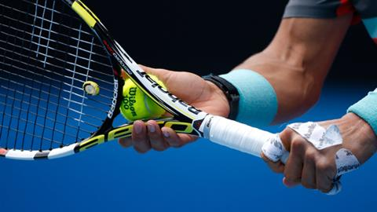](https://www.google.co.uk/url?sa=i&source=images&cd=&cad=rja&uact=8&ved=2ahUKEwimkImp4pvbAhUM8RQKHQzlDswQjRx6BAgBEAU&url=https://www.bbc.co.uk/sport/tennis/35416193&psig=AOvVaw1z58a0kEoT4xCJzPGoZ84r&ust=1527162604596714)

|  |  |  |  |
| --- | --- | --- | --- |
| **Skills (S)** | | | |
| 1 | Accuracy of service | 8 | Spin serve |
| 2 | Speed of service | 9 | Topspin |
| 3 | Accuracy of ground strokes | 10 | Slice |
| 4 | Speed of ground strokes | 11 | Volley |
| 5 | Drop shot | 12 | Backhand |
| 6 | Lob | 13 | Footwork |
| 7 | Forehand | 14 | Recovery |

[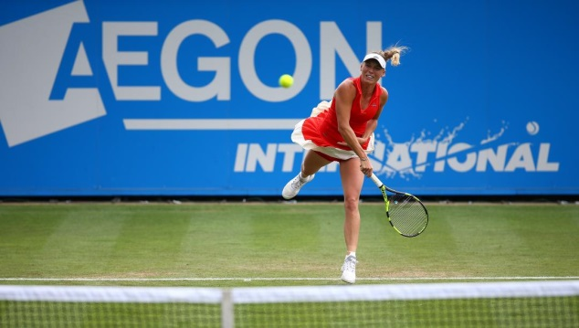](https://www.google.co.uk/url?sa=i&source=images&cd=&cad=rja&uact=8&ved=2ahUKEwiTvoGf45vbAhUCtBQKHXCWDNMQjRx6BAgBEAU&url=http://www.wtatennis.com/tournament/2017-Eastbourne&psig=AOvVaw1z58a0kEoT4xCJzPGoZ84r&ust=1527162604596714)

|  |  |
| --- | --- |
| **Tactics (T)** | |
| 1 | Ability to move your opponent around the court |
| 2 | Variation of shot |
| 3 | Attacking at the front of the court |
| 4 | Serve and volley |
| 5 | Positioning ready to receive |
| 6 | Variation of serve |
| 7 | Identifying and playing to opponents weakness |