Pic7777777

|  |  |
| --- | --- |
| **Component of Fitness (F)** | |
| 1 | Maximal Strength |
| 2 | Coordination |
| 3 | Flexibility |
| 4 | Dynamic Strength |
| 5 | Muscular Endurance |
| 6 | Balance |
| 7 | Explosive Strength |
| 8 | Power |
| 9 | Speed |
| 10 | Cardiovascular Endurance |
| 11 | Agility |
| 12 | Reaction Time |
| 13 | Static Strength |

**Cricket**

[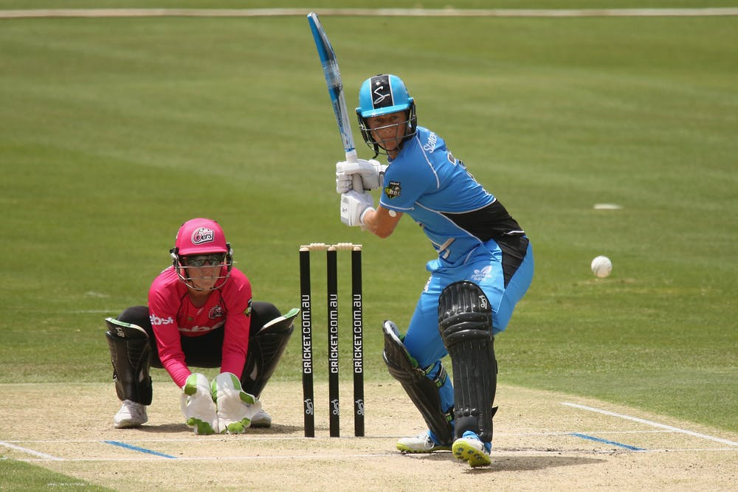](https://www.google.co.uk/url?sa=i&source=images&cd=&cad=rja&uact=8&ved=2ahUKEwiwiLuB4ZvbAhXLcRQKHebuDRoQjRx6BAgBEAU&url=http://theconversation.com/why-the-rights-to-broadcast-cricket-could-be-worth-1-billion-90845&psig=AOvVaw3vcLCNyPzCgGfSr_ZN7Roy&ust=1527162257668184)

|  |  |  |  |
| --- | --- | --- | --- |
| **Skills (S)** | | | |
| 1 | Accuracy of bowling | 11 | Forward defensive |
| 2 | Speed of bowling | 12 | Back foot defensive |
| 3 | Variation of bowling | 13 | Drive |
| 4 | Defensive batting | 14 | Cut |
| 5 | Attacking batting | 15 | Hook |
| 6 | Catching | 16 | Pull |
| 7 | Long barrier | 17 | Sweep |
| 8 | Throwing into the stumps | 18 | Leg spin |
| 9 | Running up | 19 | Off spin |
| 10 | Communication between the stumps | 20 | Googly |

|  |  |
| --- | --- |
| **Tactics (T)** | |
| 1 | Placement of fielders when bowling |
| 2 | Placement of the ball when batting |
| 3 | Spells of bowling, varying delivery |
| 4 | Backing up in the field |
| 5 | Tactical batting (Defensive) |
| 6 | Tactical batting (Attacking) |