Pic7777777

**Athletics Throw**

|  |  |
| --- | --- |
| **Component of Fitness (F)** | |
| 1 | Maximal Strength |
| 2 | Coordination |
| 3 | Flexibility |
| 4 | Dynamic Strength |
| 5 | Muscular Endurance |
| 6 | Balance |
| 7 | Explosive Strength |
| 8 | Power |
| 9 | Speed |
| 10 | Cardiovascular Endurance |
| 11 | Agility |
| 12 | Reaction Time |
| 13 | Static Strength |

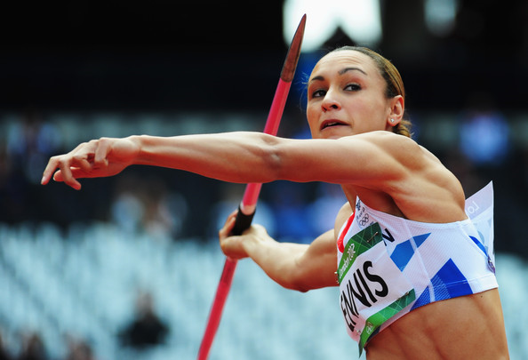

|  |  |  |  |  |  |  |  |
| --- | --- | --- | --- | --- | --- | --- | --- |
| **Skills (S)** | | | | | | | |
| **Discus** | | | **Javelin** | | **Shot Putt** | | |
| 1 | Demonstrate correct grip | 10 | | Demonstrate correct grip | | 21 | Demonstrate correct grip |
| 2 | Standing throw: Chin, knee, toe | 11 | | Standing throw: Chin, knee, toe | | 22 | Standing throw: Chin, knee, toe |
| 3 | Drive low to high | 12 | | Drive low to high | | 23 | Drive low to high |
| 4 | Angle of release | 13 | | Angle of release | | 24 | Angle of release |
| 5 | Arm is fast and last | 14 | | Arm is fast and last | | 25 | Arm is fast and last |
| 6 | Release: off index finger | 15 | | Start throw with a straight arm | | 26 | Push not throw |
| 7 | Release: Knuckles facing the sky | 16 | | Bend arm as you throw | | 27 | Elbow high |
| 8 | Release: Discus flat and spinning | 17 | | Hand is high during throw | | 28 | Glide across the circle |
| 9 | Spin: speed in the circle | 18 | | Wrist flexes on release | | 29 | Maintain low body position when gliding |
|  | | 19 | | Follow through on release | |  | |
| 20 | | Include run up | |  | |

|  |  |
| --- | --- |
| **Tactics (T)** | |
| 1 | Make sure first throw is a legal throw and is recorded. |
| 2 | Focusing 2nd or 3rd throws on distance (adding spins, gliding and run up) |
| 3 | Selecting the correct type of throw (Standing, run up, glide etc) |
| 4 | Knowledge of rules (Exit out of the circle) |