Pic7777777

|  |  |
| --- | --- |
| **Component of Fitness (F)** | |
| 1 | Maximal Strength |
| 2 | Coordination |
| 3 | Flexibility |
| 4 | Dynamic Strength |
| 5 | Muscular Endurance |
| 6 | Balance |
| 7 | Explosive Strength |
| 8 | Power |
| 9 | Speed |
| 10 | Cardiovascular Endurance |
| 11 | Agility |
| 12 | Reaction Time |
| 13 | Static Strength |

**Athletic Run**

[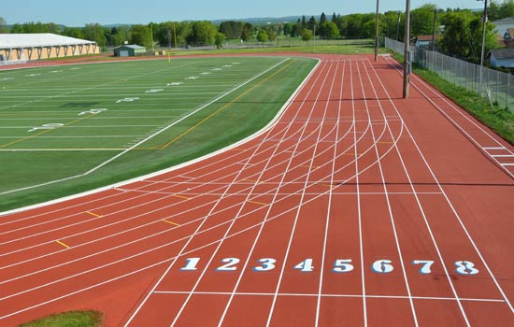](https://www.google.co.uk/url?sa=i&source=images&cd=&cad=rja&uact=8&ved=2ahUKEwi5mIjGo5vbAhVJthQKHR54BOUQjRx6BAgBEAU&url=http://www.carpell.com/en/athletics-tracks.html&psig=AOvVaw3IDI709HS9JGX-BaQKWTkj&ust=1527145771567684)

|  |  |  |  |
| --- | --- | --- | --- |
| **Skills (S)** | | | |
| 1 | Sprint start | 10 | Handing over baton timing |
| 2 | Driving of knees | 11 | Communication between relay runners |
| 3 | Driving of arms | 12 | Driving in on the bend |
| 4 | Head straight | 13 | Positioning at the start of a race |
| 5 | Slight lean of the body | 14 | Positioning during the race |
| 6 | Stride length | 15 | Attacking at the end of a race |
| 7 | Heel placement first | 16 | Running bends |
| 8 | Speed of leg drive | 17 | Pacing over distance |
| 9 | Moving before baton received (crawling) |

[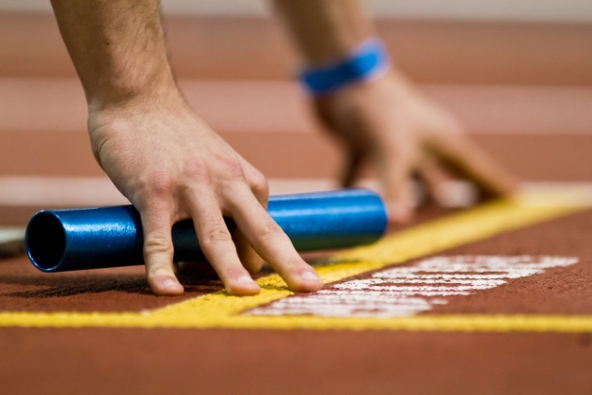](https://www.google.co.uk/url?sa=i&source=images&cd=&cad=rja&uact=8&ved=2ahUKEwjF4cni35vbAhWIzxQKHRPsBUsQjRx6BAgBEAU&url=https://www.letsrun.com/photos/2013/millrose-games/imagepages/image122.php&psig=AOvVaw0SV2czpcEVSWP1om05fHlT&ust=1527161928091958)

|  |  |
| --- | --- |
| **Tactics (T)** | |
| 1 | Order of relay runners |
| 2 | When to attack |
| 3 | Strategic positioning |
| 4 | Pacing |