Pic7777777

**Athletics Jump**

|  |  |
| --- | --- |
| **Component of Fitness (F)** | |
| 1 | Maximal Strength |
| 2 | Coordination |
| 3 | Flexibility |
| 4 | Dynamic Strength |
| 5 | Muscular Endurance |
| 6 | Balance |
| 7 | Explosive Strength |
| 8 | Power |
| 9 | Speed |
| 10 | Cardiovascular Endurance |
| 11 | Agility |
| 12 | Reaction Time |
| 13 | Static Strength |

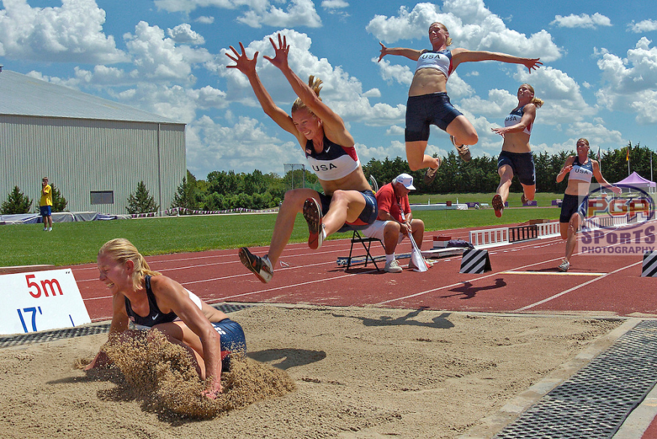

|  |  |  |  |  |  |  |  |
| --- | --- | --- | --- | --- | --- | --- | --- |
| **Skills (S)** | | | | | | | |
| **Long Jump** | | | **Triple Jump** | | | **High Jump** | |
| 1 | Focus forward | 11 | | Equal hop, step and jump phase | 21 | | Run with good posture |
| 2 | Body upright | 12 | | Extend the legs | 22 | | Run on a curve |
| 3 | Drive the knee | 13 | | Use of arm to balance leg action throughout | 23 | | Acceleration on the final 4-5 strides |
| 4 | Hips high at take-off | 14 | | Extension of the hip, knee and ankle | 24 | | Extension of the hip, knee and ankle |
| 5 | Land with heels first | 15 | | Keep tall | 25 | | Mid-upper back touches first |
| 6 | Bend the knee when landing | 16 | | Upright body in flight phase | 26 | | Push hips up to arch back |
| 7 | Look forward and up | 17 | | Fast, controlled run up | 27 | | Flick feet up |
| 8 | Fast controlled run up | 18 | | Pull foot down and back at take-off | 28 | | Lean on the angle as you approach |
| 9 | Aware of the take-off point | 19 | | Drive the free knee up and forwards | 29 | | Drive the knee at 90 degrees |
| 10 | Arm up on flight phase | 20 | | Bring take-off leg through | 30 | | Lift the legs |

|  |  |
| --- | --- |
| **Tactics (T)** | |
| 1 | Choice of jump performed |
| 2 | Length of run-up |
| 3 | Height of entry jump |
| 4 | Distance of entry jump |
| 5 | Knowledge of rules |