Pic7777777

**Rugby**

|  |  |
| --- | --- |
| **Component of Fitness (F)** | |
| 1 | Maximal Strength |
| 2 | Coordination |
| 3 | Flexibility |
| 4 | Dynamic Strength |
| 5 | Muscular Endurance |
| 6 | Balance |
| 7 | Explosive Strength |
| 8 | Power |
| 9 | Speed |
| 10 | Cardiovascular Endurance |
| 11 | Agility |
| 12 | Reaction Time |
| 13 | Static Strength |

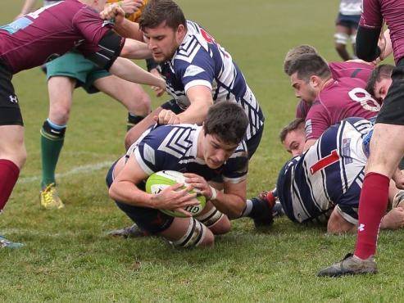

|  |  |  |  |
| --- | --- | --- | --- |
| **Skills (S)** | | | |
| 1 | Passing | 8 | Positions in the scrum |
| 2 | Catching | 9 | Kicking (drop kick) |
| 3 | Taking the ball into contact | 10 | Kicking (conversion) |
| 4 | Tackling | 11 | Fixing defenders |
| 5 | Mauling | 12 | Presenting the ball |
| 6 | Rucking | 13 | Grubber |

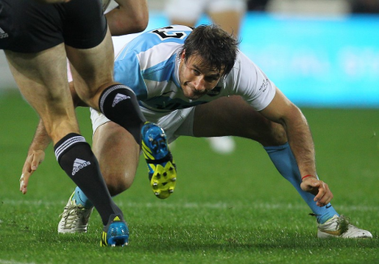

|  |  |
| --- | --- |
| **Tactics (T)** | |
| 1 | Attacking options |
| 2 | Defensive options |
| 3 | Pass selection |
| 4 | Joining/conceding a ruck |
| 5 | Set play selection |