Pic7777777

**Netball**

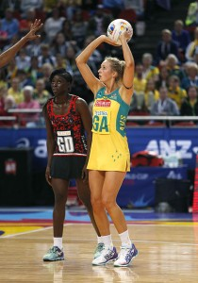

|  |  |
| --- | --- |
| **Component of Fitness (F)** | |
| 1 | Maximal Strength | |
| 2 | Coordination | |
| 3 | Flexibility | |
| 4 | Dynamic Strength | |
| 5 | Muscular Endurance | |
| 6 | Balance | |
| 7 | Explosive Strength | |
| 8 | Power | |
| 9 | Speed | |
| 10 | Cardiovascular Endurance | |
| 11 | Agility | |
| 12 | Reaction Time | |
| 13 | Static Strength | |

|  |  |  |  |
| --- | --- | --- | --- |
| **Skills (S)** | | | |
| 1 | Catching | 8 | Rebounding |
| 2 | Catching on the move | 9 | Shooting |
| 3 | Footwork | 10 | Intercepting |
| 4 | Chest pass | 11 | Pivoting |
| 5 | Bounce pass | 12 | Marking |
| 6 | Shoulder pass | 13 | Dodging |

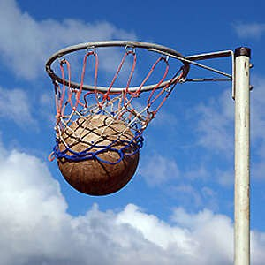

|  |  |
| --- | --- |
| **Tactics (T)** | |
| 1 | Holding space |
| 2 | Creating space |
| 3 | Centre pass |
| 4 | Side line |
| 5 | Back line |