|  |  |
| --- | --- |
| **Leadership (L)** | |
| 1 | Confidence when leading a group |
| 2 | Ability to motivate a group being led |
| 3 | Communication skills |
| 4 | Use of demonstrations to support understanding |
| 5 | Suitability of drills/tasks being led |
| 6 | Empathy with the group being led |

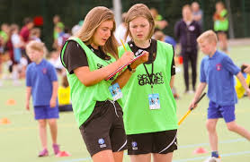

|  |  |
| --- | --- |
| **Analysis & Evaluation (A)** | |
| 1 | Identification of strengths and weaknesses |
| 2 | Justification of strength and weaknesses using examples from game situations |
| 3 | Ability to identify the demands of the sport (what is important and why) |
| 4 | Ability to identify a type of training that would improve a fitness component weakness |
| 5 | Ability to plan a session to improve a weakness |

[](https://www.google.co.uk/url?sa=i&source=images&cd=&cad=rja&uact=8&ved=2ahUKEwj88YKXppvbAhWDzxQKHTNiD2oQjRx6BAgBEAU&url=https%3A%2F%2Fmoodle.glyndwr.ac.uk%2Fcourse%2Fview.php%3Fid%3D18865&psig=AOvVaw1F8Q9OaV81klSqkejGQ4iH&ust=1527146437259191)